**CONTENTS**

**Chapter 1: INTRODUCTION**

* 1. Introduction
     1. Definition of Blockchain
     2. Why Blockchain is important?
     3. Key Elements of Blockchain
     4. Working Behind Blockchain
     5. Types of Blockchain
  2. Literature Review

**Chapter 2: THE PROJECT**

2.1 Project definition

2.1.1 Economic Problems

2.1.2 Managerial Problems

2.1.3 Expenditure Statistics of EVMs

2.2 Objective of Project

2.2.1 Project scope

2.2.2 Proposed Methodology

**Chapter 3: REQUIREMENTS ANALYSIS** (Depends on the project kind)

3.1 Functional Requirements

3.2 Non-Functional Requirements

3.3 Use-Case specifications

3.3.3 Find Use Cases

3.3.4 Use Case Diagrams

**Chapter 4: DESIGN** (Depends on the project kind)

4.1 Database Design

4.1.1 ER Diagram

4.2.2 Design Tables and Normalization

4.2 Architecture diagrams  
 4.2.1 Low Level Design

4.3 Sequence diagrams

**Chapter 5: EXPERIMENT AND TESTING**

5.1 Test cases developed.

5.2 Testing used in our project.

**Chapter 6: CONCLUSION** (Anticipatory approach)

6.1 Problems and Issues in currents system

6.2 Future extension

**APPENDIX: (Research Paper)**

**BIBLIOGRAPHY AND REFERENCE (APA Style)**

**Scope of Project**

The scope of the final project is to research the possibility to design a decentralized e-voting system and implement a prototype as a proof of concept that assures transparency, privacy, correctness, and integrity.

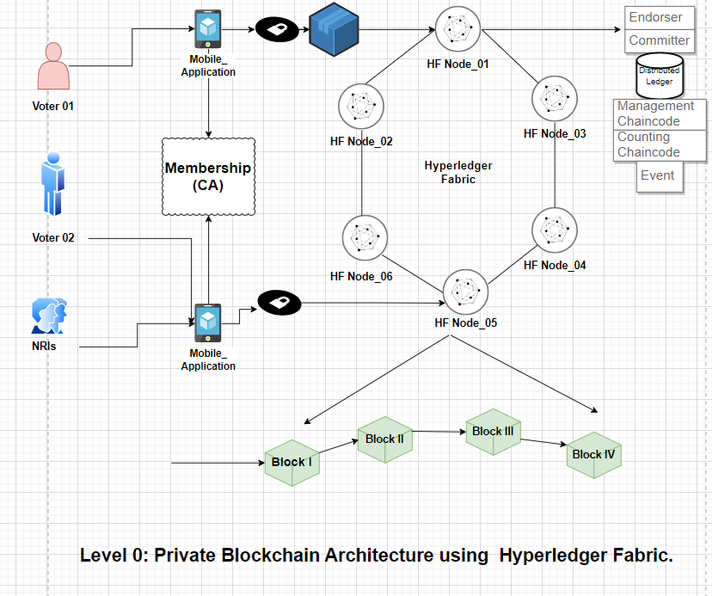

**In above figure, we have three end user entities i.e., Voter_01, Voter_02 & NRIs**

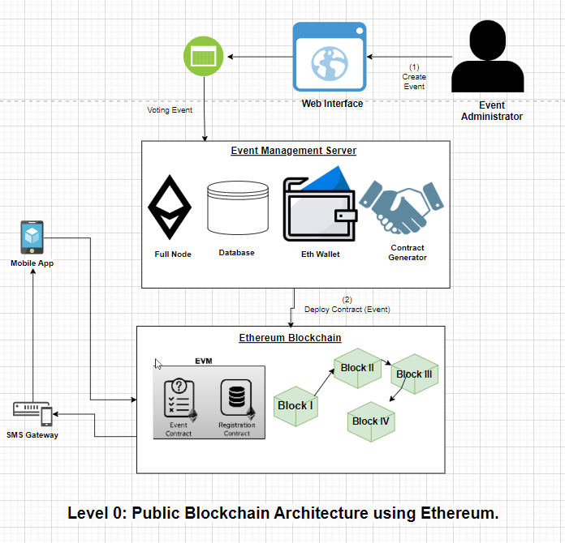

**In above figure, we have one Event Administrator which has control to create an event & manage our Event Management Server. This Event Management Server(EMS) Contains four main components i.e. Full Node, Database, Wallet & Contract Generator.  
Now this EMS, is connected with the main Ethereum Blockchain which contains four blocks where our Consensus Algorithm is running.**

**Proposed Methodology**

**Algorithmic Steps :**

1. Voter need to enter his/her credentials in order to vote.

2. All data is then encrypted and stored as a transaction.

3. This transaction is then broadcasted to every node in network, which in turn is then verified.

4. Network approves transaction, it is stored in a block and added to chain.

5. Block is added into chain, it stays there forever and can’t be updated.

6. Users can now see results and also trace back transaction if they want

**Functional Requirements**

1. Software Requirements ]
   1. OS: Windows 10 Pro, Ubuntu 20.04 LTS.
   2. Framework: Visual Studio Code.
   3. Server: Localhost.
   4. Database: MS-SQL Server 2012/2014.
2. Hardware Requirements
   1. Processor: Intel(R) Core(TM) i7-9750H [CPU@2.60GHz](mailto:CPU@2.60GHz)
   2. HD: Minimum 15 GB of HDD.
   3. RAM: Minimum 12 GB of RAM.

Non-Functional Requirements

**Non-functional requirements or NFRs** are a set of specifications that describe the system’s operation capabilities and constraints and attempt to improve its functionality. These are basically the requirements that outline how well it will operate including things like speed, security, reliability, [data integrity](https://www.altexsoft.com/blog/data-integrity/), etc.

Use-Case specifications

A [**Use Case Specification**](https://www.modernanalyst.com/Resources/Articles/tabid/115/ID/2016/End-to-End-UML-Use-Case-Specification.aspx) is a textual description of the functionality provided by the system. It captures actor-system interaction. That is, it specifies how a user interacts with a system and how the system responds to the user actions. It is often phrased in the form of a dialog between the actor and the system. The use case specification is represented in the use case diagram by an oval, and is what most people think of when they hear the term use case.

Find Use Cases

Use Case Diagrams

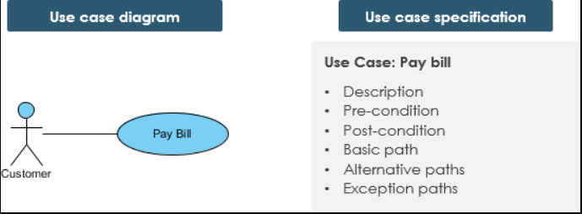

4.1 Database Design

4.1.1 ER Diagram

4.2.2 Database Design Tables

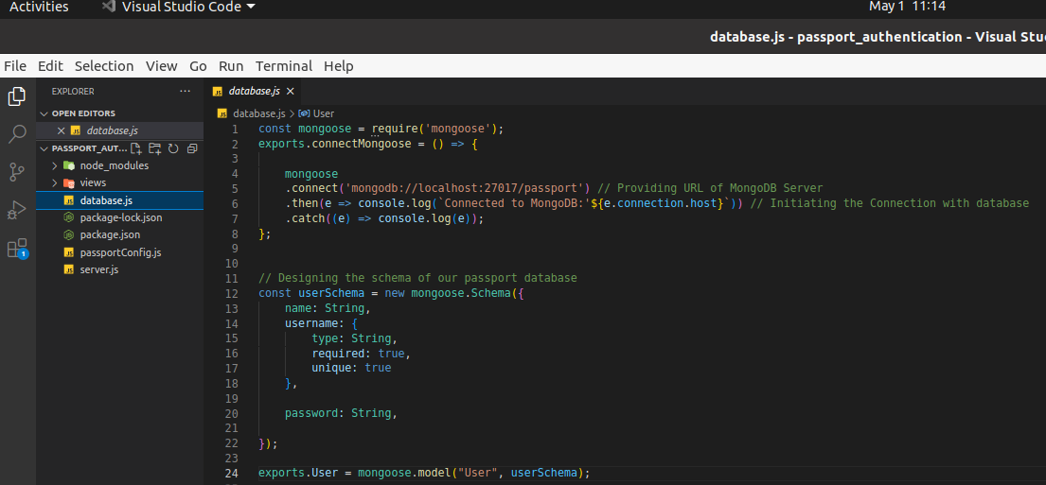  
Figure : Showing database.js file

4.2 Architecture diagrams

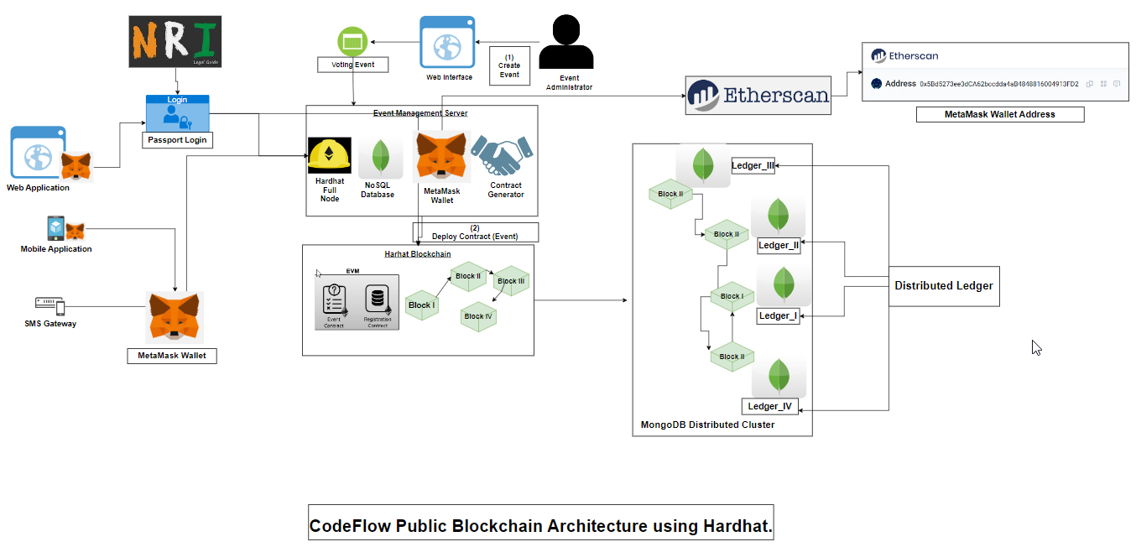  
Figure 2: Showing Entire Code flow using Hardhat

In Figure 2, we are explaining the complete architecture CodeFlow of our decentralized E-Voting application using Hardhat as blockchain platform.[12] Here, in Front-End Part we designed 3 ways i.e. User can login using web application, mobile application or even via SMS Gateway (for Tier-2 & Tier-3 cities). Also, NRIs can login with passport login, while others can login with MetaMask wallet.[13] After successful login, we can create voter's & candidates. As MetaMask is verified, voter registration can be accepted and also, we can see the voter list.[14] In create new voter, voter can upload photo, user name, address of MetaMask, age. By using hardhat blockchain - block I is connected to Block II and so on.[15] Hardhat blockchain is connected to MongoDB for NRI users and distributed ledger are created. Event Management Server is connected to Etherscan[16] block explorer and analytics platform for Ethereum. All of the process of authentication the Administrator can have all access to allow list of voters and have all the rights for the security reasons. We setup MongoDB Compass as distributed ledger cluster in which each node has its own ledger for maintaining the entire state of cluster as it works on Consensus algorithm

4.4 Sequence diagrams

4.4.1 Directory Structures

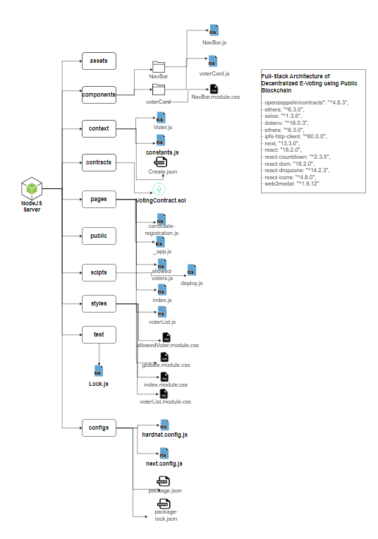  
Figure 3: Showing entire directory structure of project

As shown in Figure 3, we explained our Full-Stack directory-level tree structure where we created directories i.e., assets, components, context, contracts, pages, scripts, styles, test & configs.[17] In components, we have Navbar, voter Card which includes NavBar.js, voterCard.js & NavBar.module.css etc. In context we created Voter.js, constants.js & Create.json etc. In pages directory, we created candidate_registration.js, _app.js, allowed-voters.js, voterList.js etc. In scripts we created deploy.js. Under styles directory, we created allowedVoter.module.css, globals.module.css, index.module.css, voterList.module.css. In test directory, we created Lock.js file. In configs file, we hardhat.config.js, next.config.js, package.json, package-lock.json. There are multiple dependencies used in this project such as openzeepelin, axios, ethers, hardhat, ipfs-http-client, dot-env, web3modal

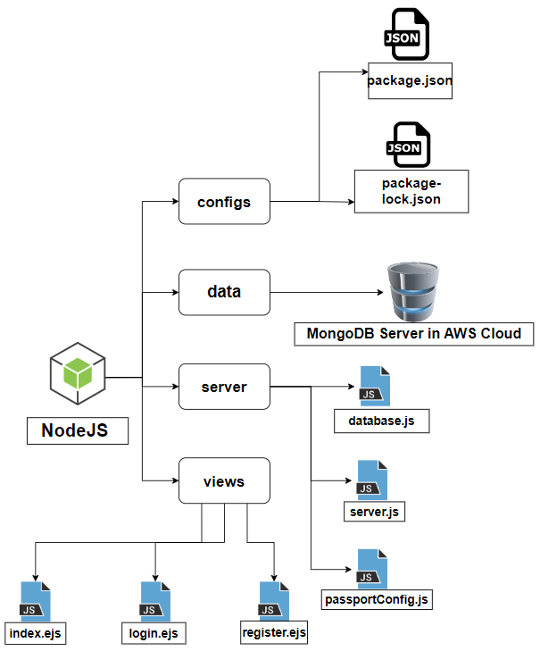Figure 4: Showing entire directory structure of ***passport authentication system***for NRIs login.

As shown in Figure 4, we explained our entire directory-level tree structure where we created directories i.e., configs, data, server & views. In server directory we created database.js, server.js & passportConfig.js. Inside *database.js* file we created the database schema which contains all the collection name & their datatype. We have three main fields i.e., *passport_no, name, email-id & password.* In views directory, we created index.ejs, login.ejs & register.ejs. The. ejsextension is *embedded javascript file.*In scripts we created deploy.js. In configs file, we created package.json, package-lock.json. There are multiple dependencies used in this project such as ejs, express, express-session, local, mongoose, nodemon, passport, passport-local etc

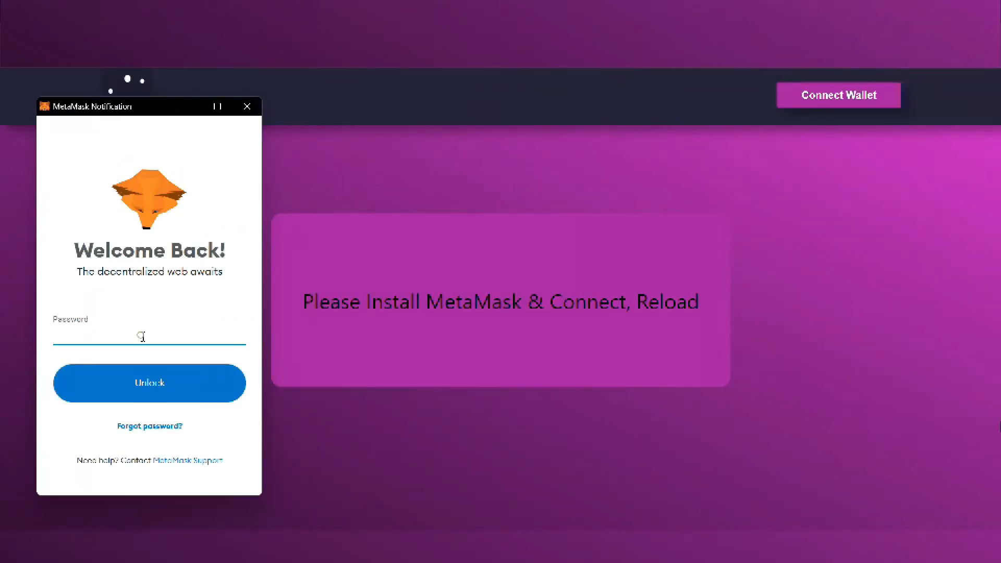Figure 5: Picture depicting *Connection with MetaMask.*As shown in figure 5, we are connecting with MetaMask Account by clicking on Connect Wallet. Then, MetaMask will connect it to Etherscan by calling API mentioned in context/constansts.js.  
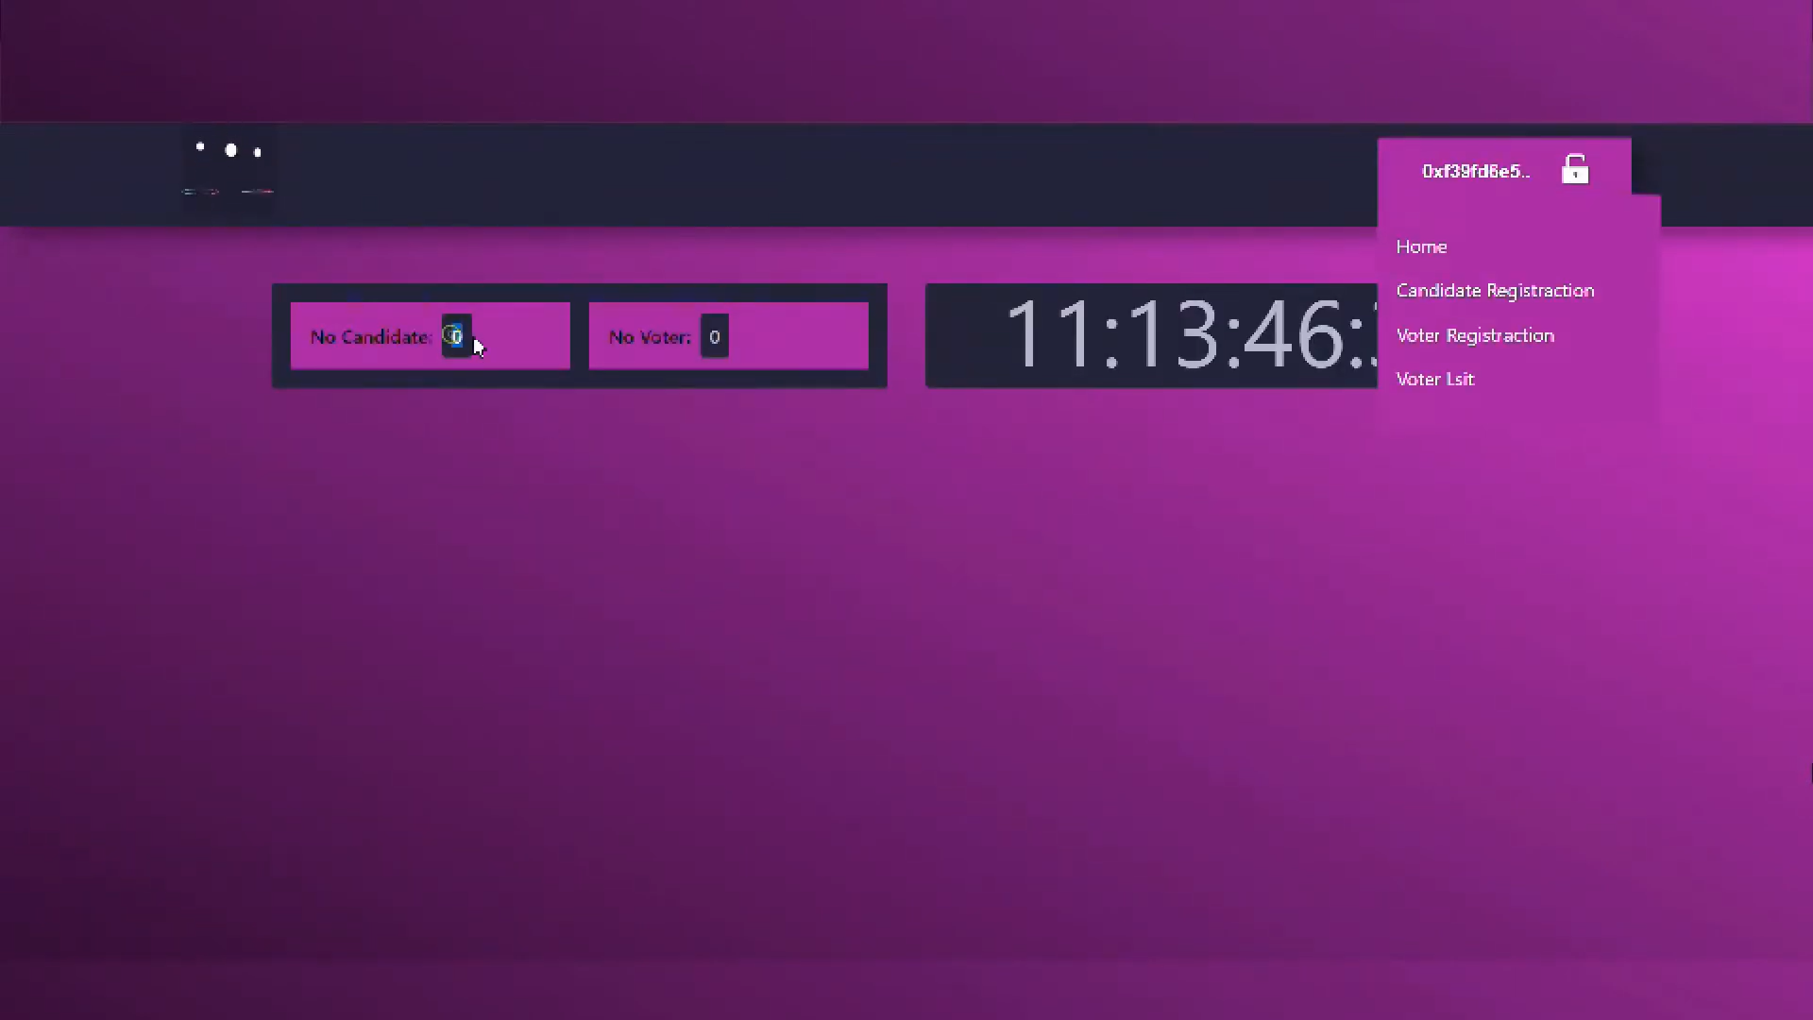Figure 6: Selecting option of Candidate Registration  
As displayed in figure 6, now we are using candidate-register.js file for registering our candidate. Also, in the figure it is showing No. of Candidate’s & No. of Voter’s in this page.

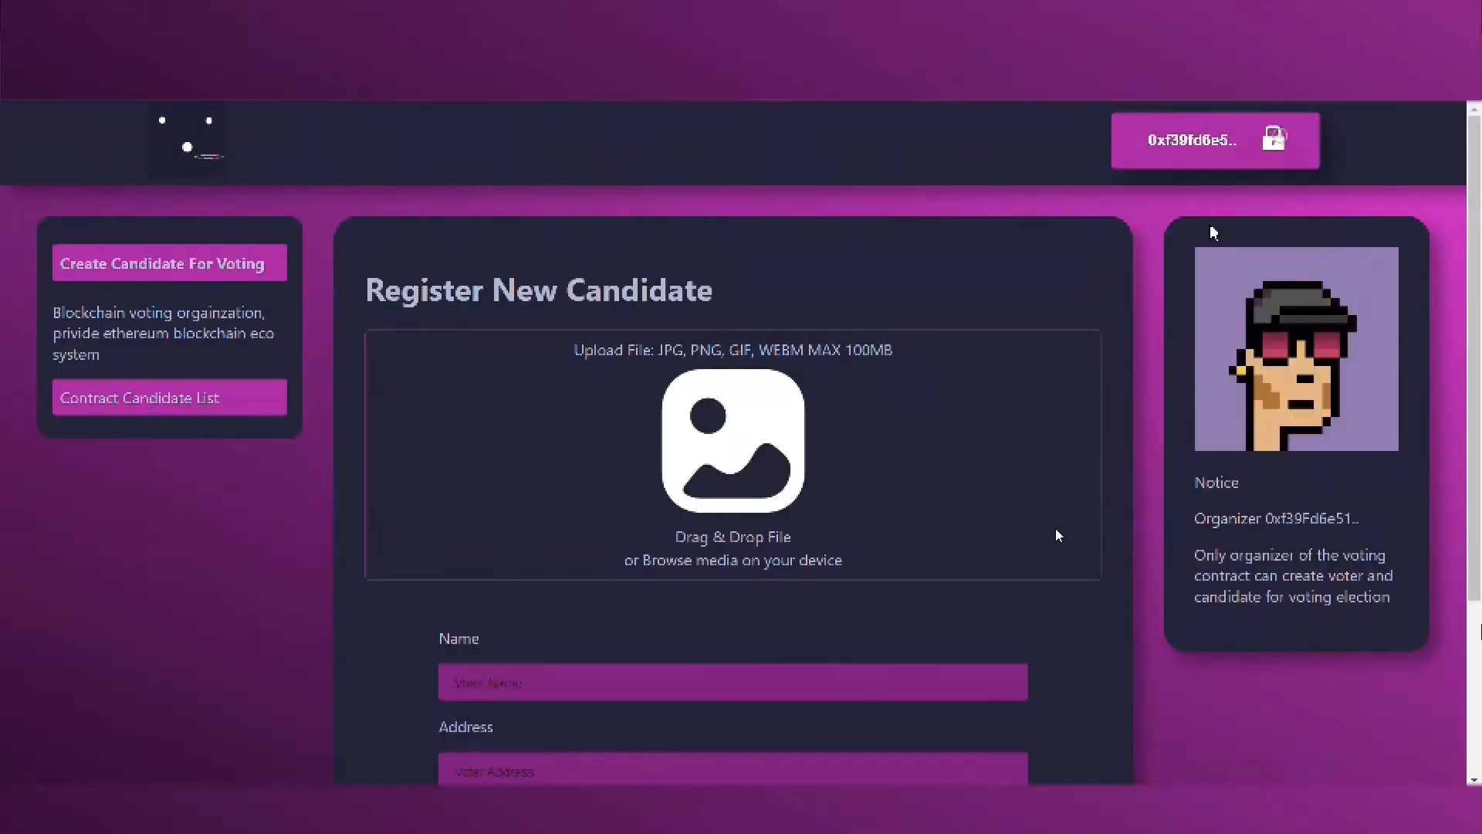Figure 7: Register New Candidate by filling *Name, Address, Position etc.*

In figure 7, we have created a web form which takes name of candidate, Address from which location it belongs & for the post he/she is contesting for. Here, candidate can also upload his/her image. 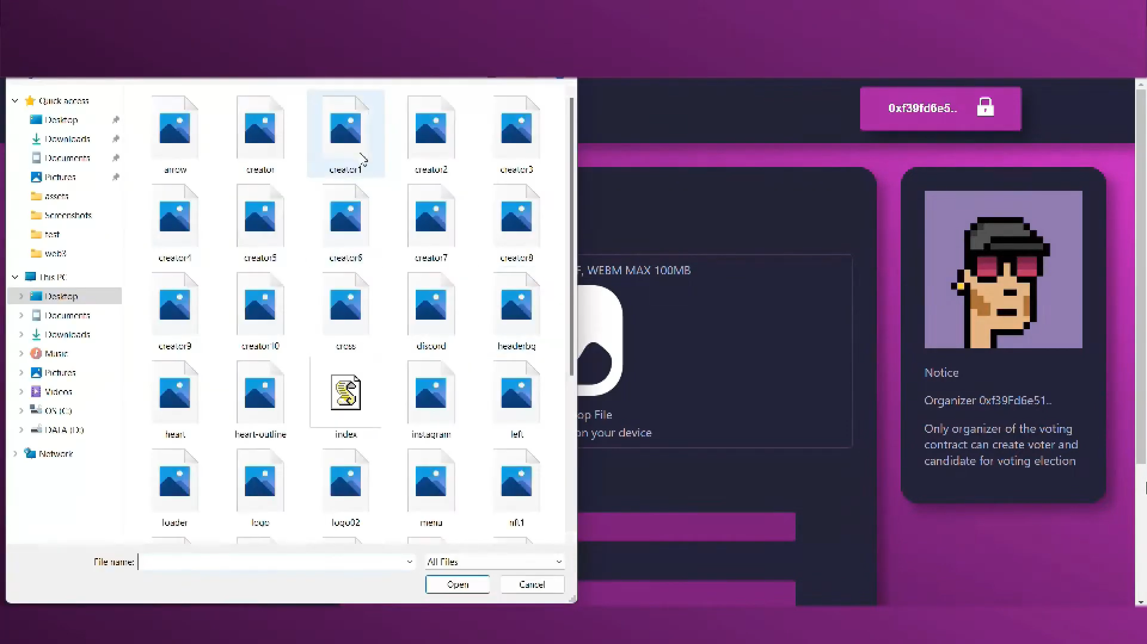Figure 8: Select *‘Candidate Photo’* for upload.In figure 8,candidate is selecting his/her photo by using index.js file & uploading images present in assets directory. Also, these images are stored in local database. 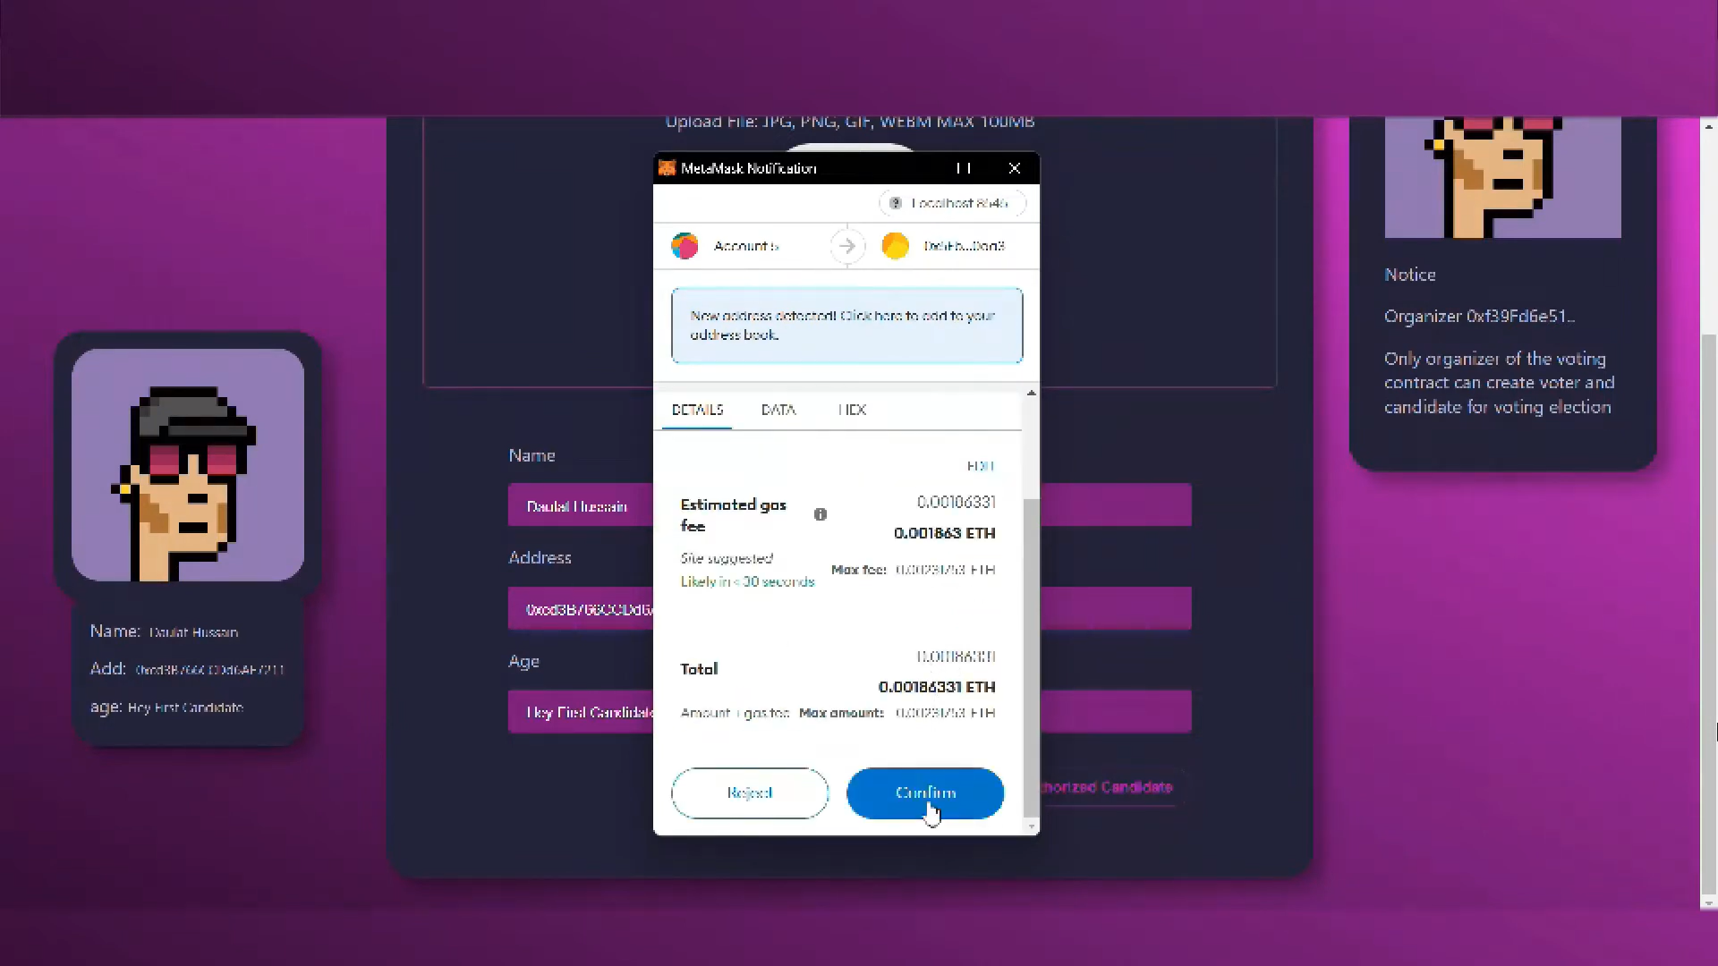Figure 9: Confirming *Ethereum Gas* for candidate registration.  
In figure 9, after filling all the form details such as name, address & position, candidate clicked on Authorized Candidate. After that, MetaMask wallet address with registered account gets initiated & Ethereum (ETH) gas fee gets deducted from MetaMask wallet. 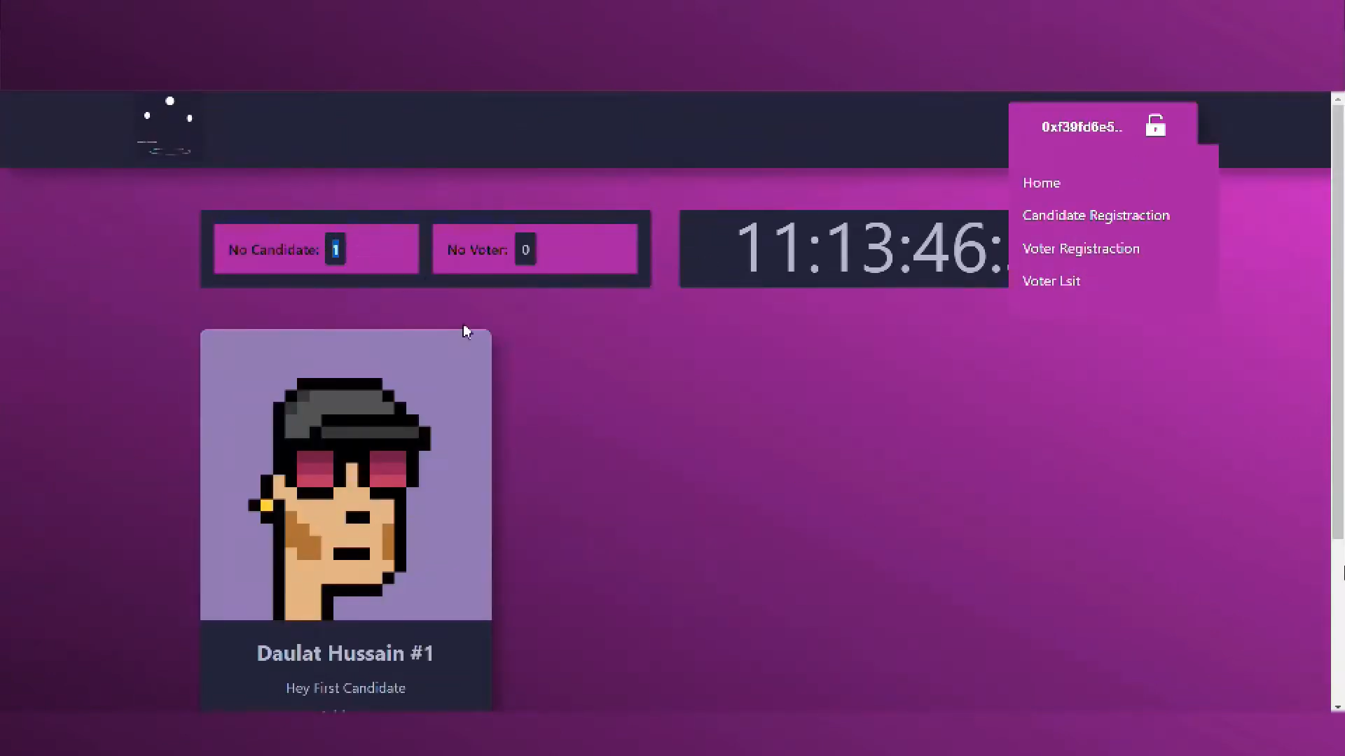Figure 10: Candidate is successfully registered.

In this figure 10, we successfully registered our candidate, also the status of Number of Candidates gets incremented by one.  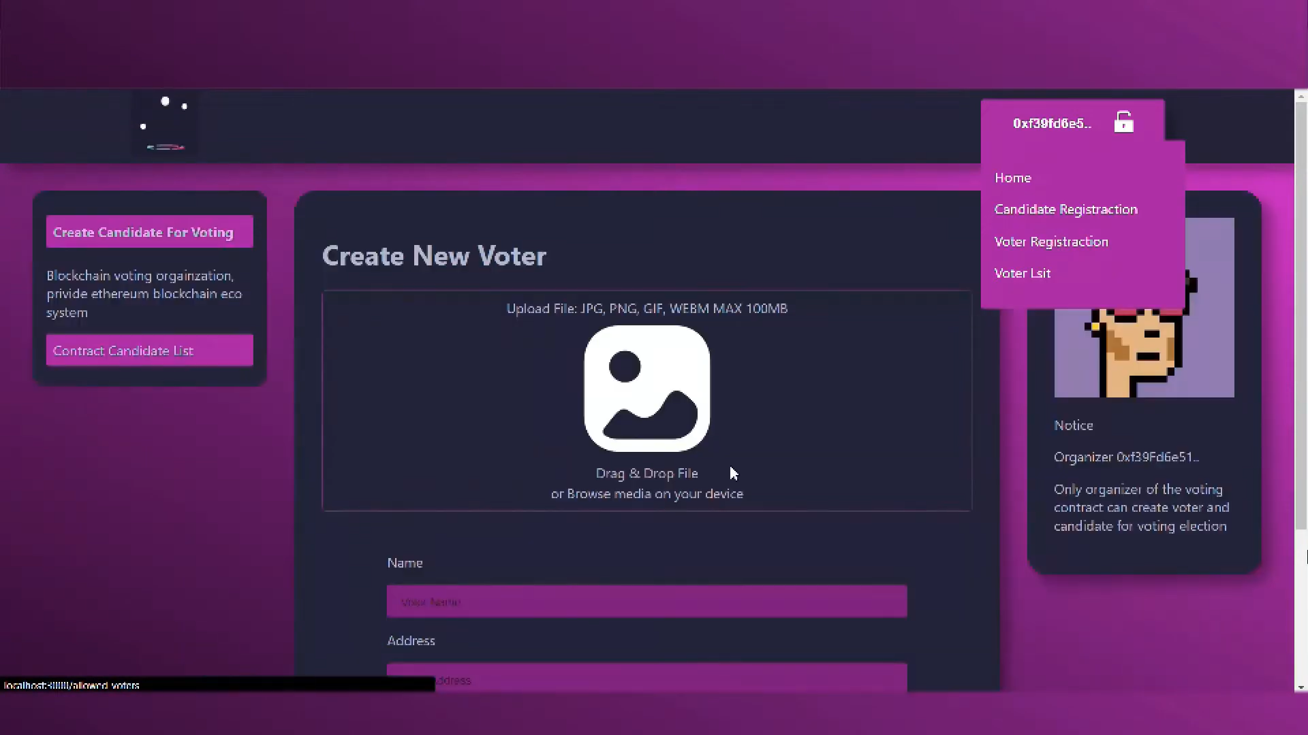Figure 11: *Create New Voter* by filling *Name, Address, Age****.*** In the figure 11, after filling all the form details such as name, address & age, voter clicks on Authorized Voter.   
  
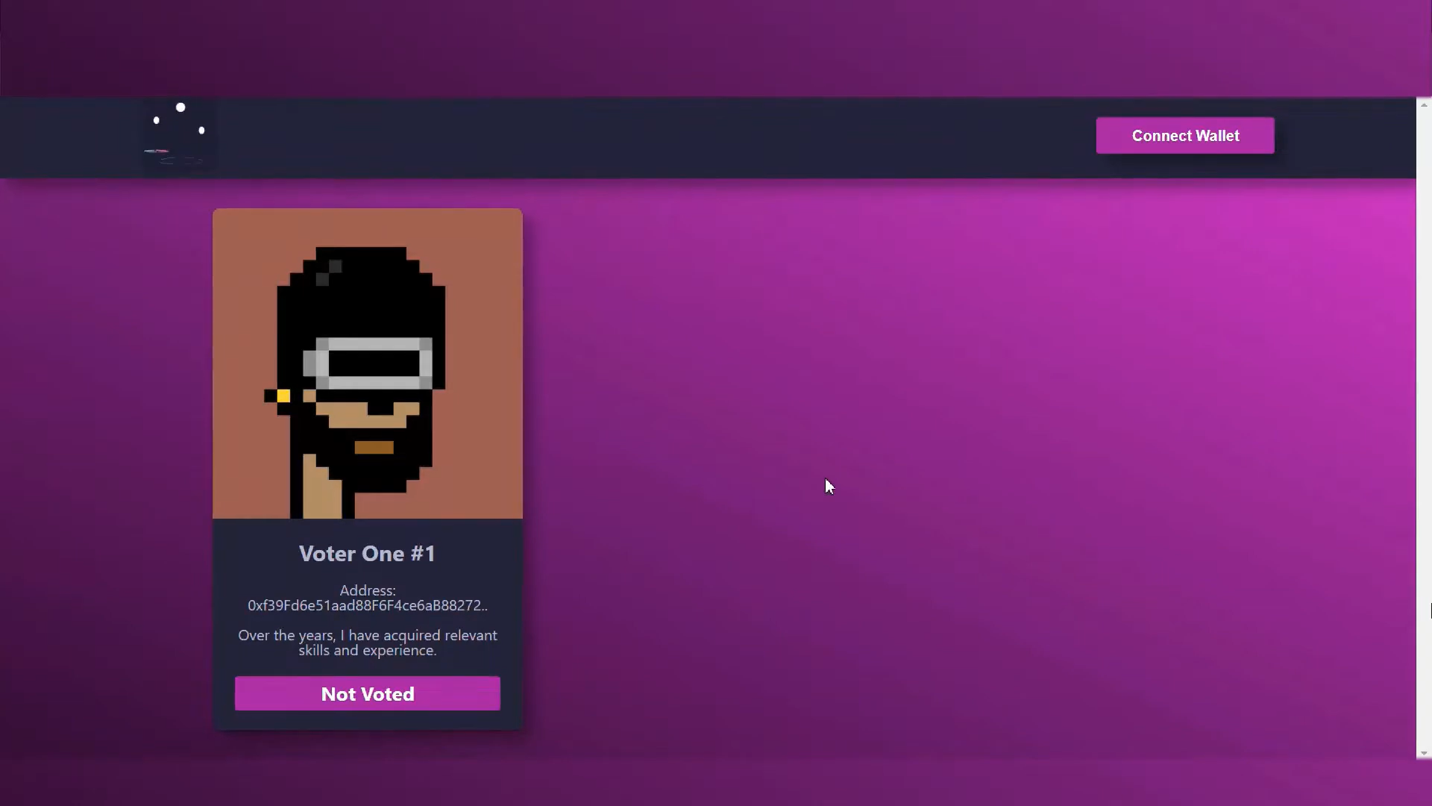Figure 12: Page showing status of Voter_One#1 i.e. *Not Voted.*In above figure 12, the Voter is created successfully, yet he/she hasn’t voted i.e., displayed as Not Voted. This method of contract is coded in VotingContract.sol file under contracts directory.

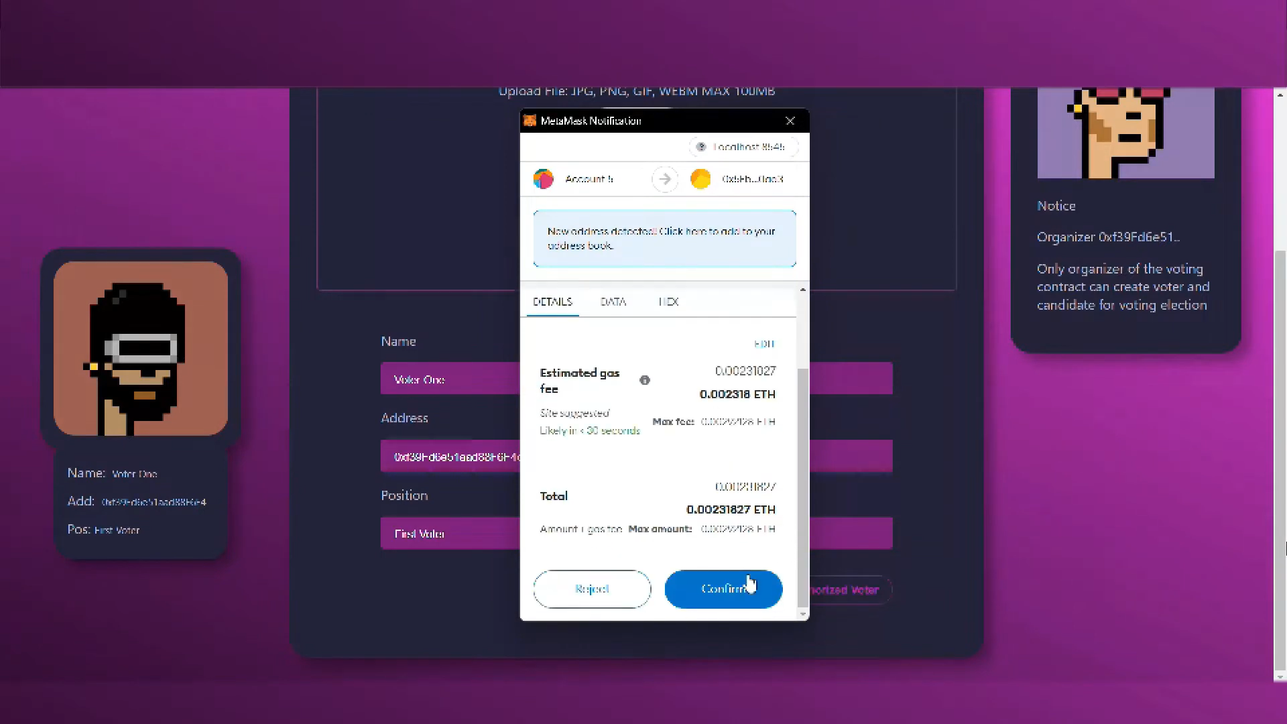Figure 13: *Voter* successfully casted his vote.  
As mentioned in figure 13, MetaMask wallet address with registered account gets initiated & Ethereum (ETH) gas fee gets deducted from MetaMask wallet as voter clicks on Confirm button. The vote gets casted. All these transaction histories can be seen in Etherscan platform. 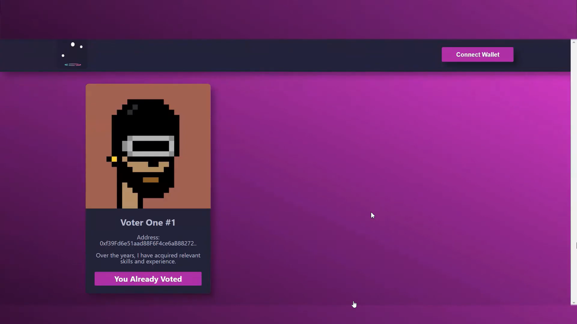Figure 14: Page showing status of Voter_One#1’s vote i.e. *You Already Casted.* As shown in figure 14, the status of voter from Not Voted to You Already Voted gets changed. The time taken by showing this status is very less.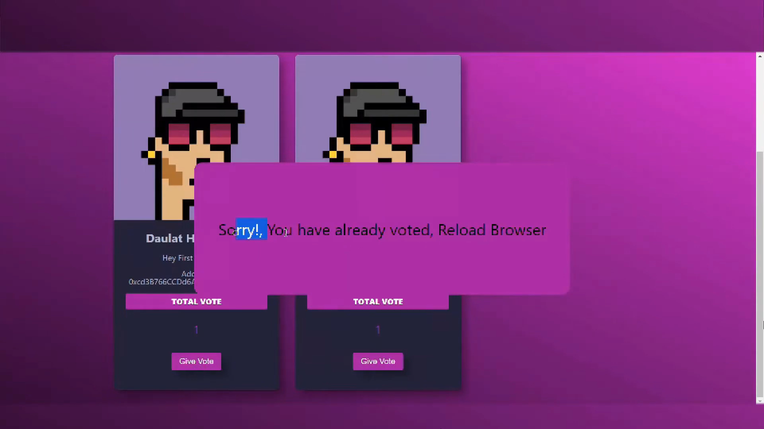  
Figure 15: *You Already Voted* status so that *One Person, One Vote.*As mentioned in figure 15, the solidity file i.e., VotingContract.sol inside contracts directory. It is hard-coded that one voter can only cast vote for single use as each voter has unique wallet address associated with their private key.

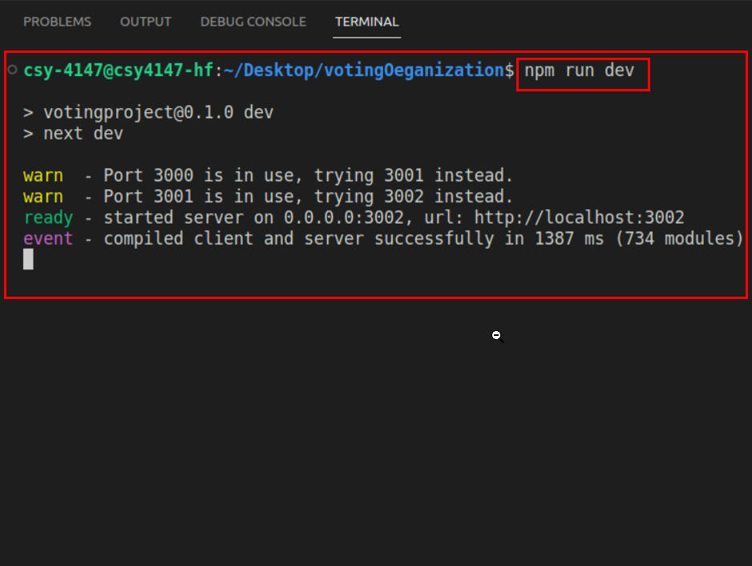Figure 16: ***Nodejs*** server successfully hosted at localhost:3001  
In this figure 16, we are starting our NodeJS server with the use of Node Package Manager(NPM) by providing run as option. Also, our server gets started on <https://localhost:3001> as 3001 port number.

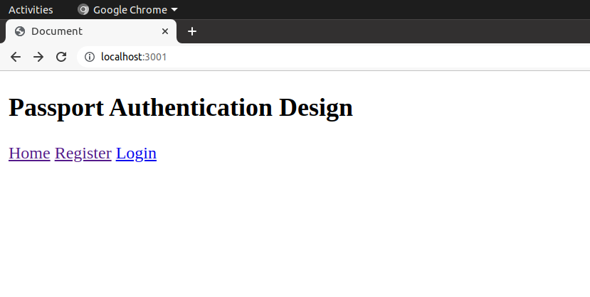Figure 17: Basic passport authentication design containing web pages i.e., ***Register*** & ***Login.***The figure 17 shows the passport authentication for all the NRIs. Here, we created a basic design to provide an idea how we can cast NRIs vote using their Passport’s. This page is linked to MongoDB Compass database in backend.

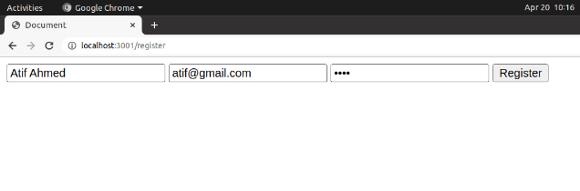Figure 18: User Registration is successfully   
As mentioned in figure 18, the voter is registering so that he/she can cast the vote but the credentials used are passport related.

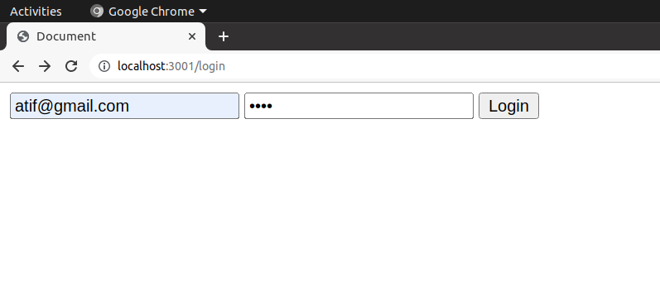Figure 19: Registered User successfully ***login***.  
Previously the user/voter gets registered, now in figure 19 the user/voter can login via same credentials & then redirected to

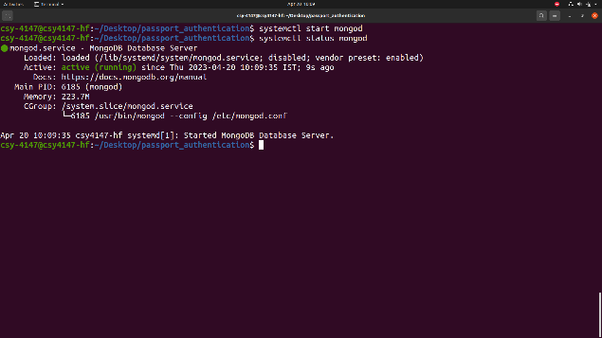Figure 20: Starting ***mongod*** daemon for deploying database server  
As displayed in figure 20, MongoDB Community Server is started in Ubuntu 20.04 using systemctl utility & connected with Passport Authentication Design Module.

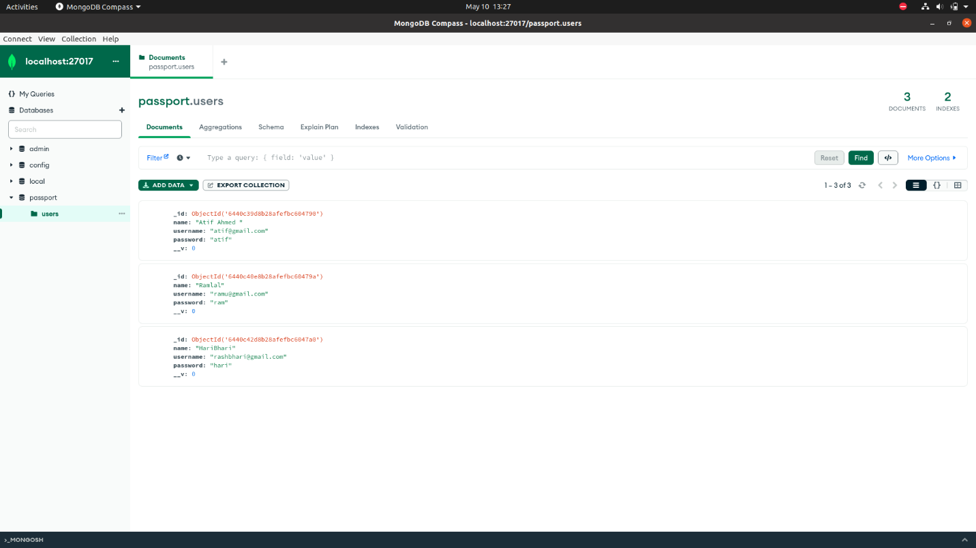Figure 21: Registered user’s data saved in ***Mongodb Compass*** locally.  
In this figure 21, all the Registered user’s data i.e., name, email & password is stored in MongoDB Database Server where the database name is *passport* & collection name is *users*. All these details are in database.js file.

5.1 Test cases developed.

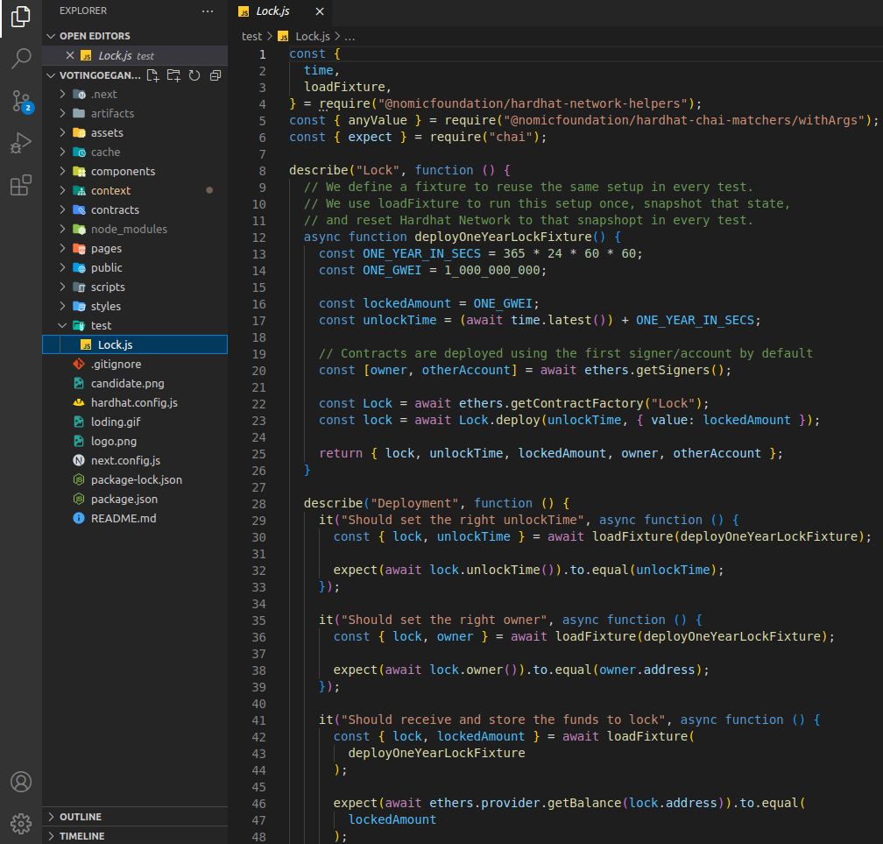

Figure:

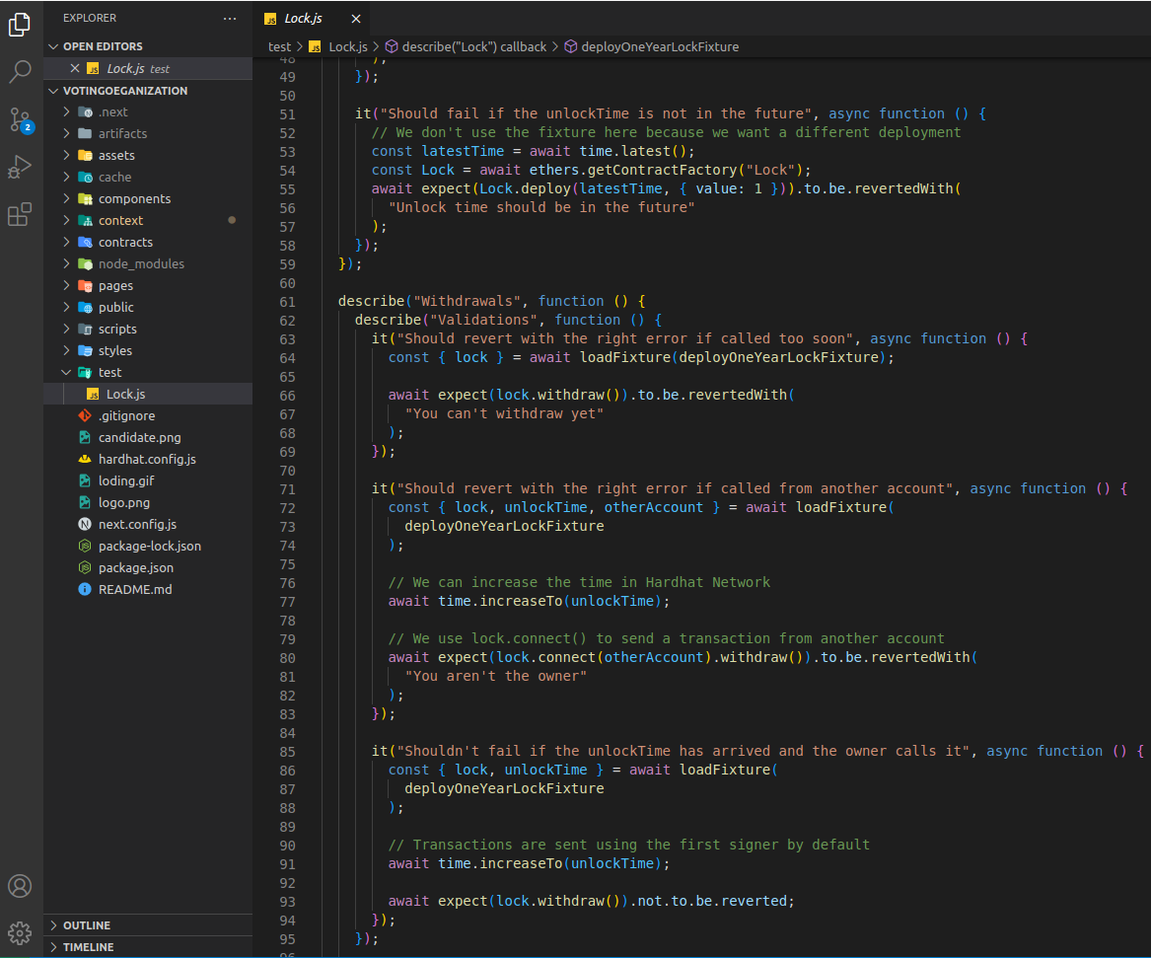

Figure:

5.2 Testing used in our project.

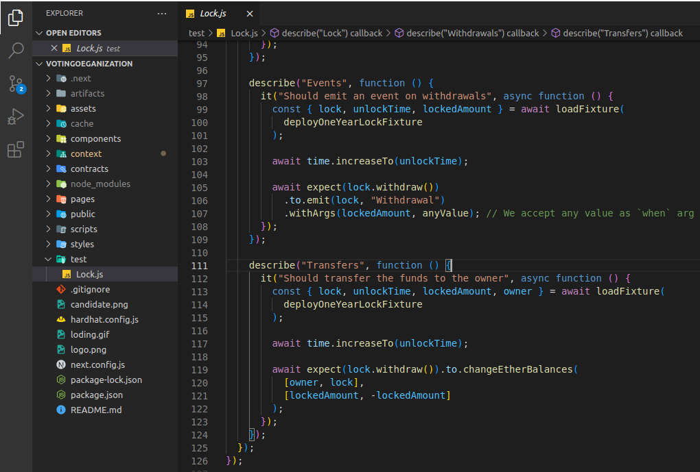

**Figure: Depicting**